Single Factor Designs

Class Examples – data posted in StatCrunch Group

1. The following is a partial analysis of variance table for 5 treatments and a total of 30 observations of the response variable. Complete the table and test the null hypothesis of no treatment differences, on average.

|  |  |  |  |  |  |
| --- | --- | --- | --- | --- | --- |
| Source | df | SS | MS | F-value | p-value |
| Treatments |  |  | 10 |  |  |
| Error |  |  |  |  |  |
| Total |  | 100 |  |  |  |

2. A filling operation consists of four identical machines that are set to pour a specified amount of a product into equal-sized containers. Random samples are taken periodically from the machines to check the equality of the average amounts poured by the machines. The following sample data were recorded for a particular time period.

Machine1 Machine2 Machine3 Machine4

15 18 18 19

14 19 18 20

15 18 19 18

16 18 17 19

14 19 19 18

16 19 18 19

Where G2=178929 and ∑∑x2 =7523

| **Column** | **n** | **Variance** | **Sum** |
| --- | --- | --- | --- |
| Machine1 | 6 | 0.8 | 90 |
| Machine2 | 6 | 0.3 | 111 |
| Machine3 | 6 | 0.56666667 | 109 |
| Machine4 | 6 | 0.56666667 | 113 |

**Use the information above to complete the ANOVA table below**

| **Source** | **DF** | **SS** | **MS** | **F-Stat** |
| --- | --- | --- | --- | --- |
| Treatment |  |  |  |  |
| Error |  |  |  |  |
| Total |  |  |  |  |

3. Independent random samples from four different brands of recently produced alkaline batteries were placed on a life test. The following lifetimes (in minutes) were observed:

|  |  |  |  |
| --- | --- | --- | --- |
| **Brand A** | **Brand B** | **Brand C** | **Brand D** |
| 110 | 118 | 108 | 117 |
| 113 | 116 | 107 | 112 |
| 108 | 112 | 112 | 115 |
| 115 | 117 | 108 | 119 |

Where G = 1807 and ∑∑x2 =204311

(a) State the null and alternative hypotheses for this study.

(b) Use the output and graphs below to check the assumptions have been met.

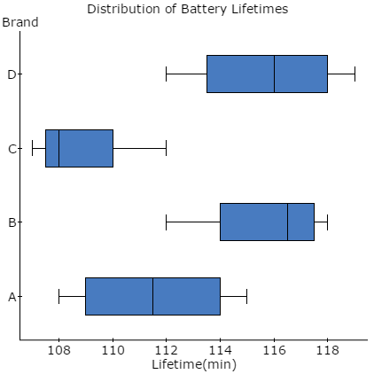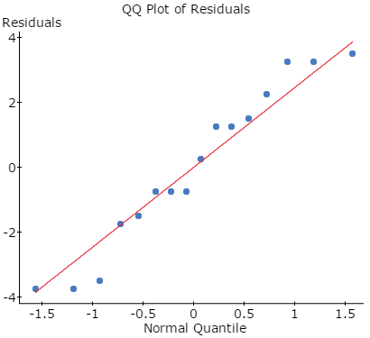

**Levene's Test for Homogeneity of Variance**

| **Test Statistic** | **DF 1** | **DF 2** | **P-value** |
| --- | --- | --- | --- |
| 0.33918129 | 3 | 12 | 0.7974 |

**(c) Complete the ANOVA table below**

**ANOVA table**

| **Source** | **DF** | **SS** | **MS** | **F-Stat** | **P-value** |
| --- | --- | --- | --- | --- | --- |
| Brand |  |  |  |  | 0.0086 |
| Error |  |  |  |  |  |
| Total |  |  |  |  |  |

(d) Interpret your results